SWASTHYA SENSE — System Architecture
Oct 31, 2026 · @Shama

1. Architecture overview and tech stack
SWASTHYA SENSE is a modular monolith: one deployable backend with clearly separated modules, a mobile-first web app, a relational database, and a scheduler. This keeps the build fast enough for a hackathon while leaving clean seams to split into services later.
Design principles
- Privacy by default: minimal fields, encrypted sensitive values, synthetic data only.
- Every call is gated: authentication, role check, patient-assignment check, consent check, then audit write.
- Rules are data, not code: rule definitions are versioned records, so they can be read, explained and approved.
- Deterministic and explainable: no black-box model in the prototype; the same input always gives the same flag and reason.
- Simulated edges: messaging runs against a simulator behind the same interface a real gateway would use.
Technology choices
Layer | Choice | Why
Frontend | React (Next.js) with TypeScript, Tailwind, installable PWA | Mobile-first, fast to build, works on low-end phones, offline shell
Backend API | Python FastAPI | Quick to write, automatic API docs, strong typing with Pydantic
Database | PostgreSQL | Relational integrity, row-level security option, JSON columns for rule definitions
Scheduler and jobs | APScheduler (upgradable to Celery with Redis) | Simple cron-style jobs; clear upgrade path
Auth | JWT sessions with role claims, hashed passwords (argon2) | Simple, standard, testable
Messaging layer | Gateway interface with a simulator implementation | Real SMS/WhatsApp providers can be dropped in later
Rules engine | Python evaluator over versioned JSON rule definitions | Transparent and easy to explain to judges and clinicians
Packaging | Docker Compose | One command to run locally and in the demo
Testing | Pytest for rules and RBAC, Playwright for the demo path | Proves the engine against seeded scenarios
Swapping any single choice (for example Node for FastAPI) does not change the architecture.

2. High-level architecture and data flow
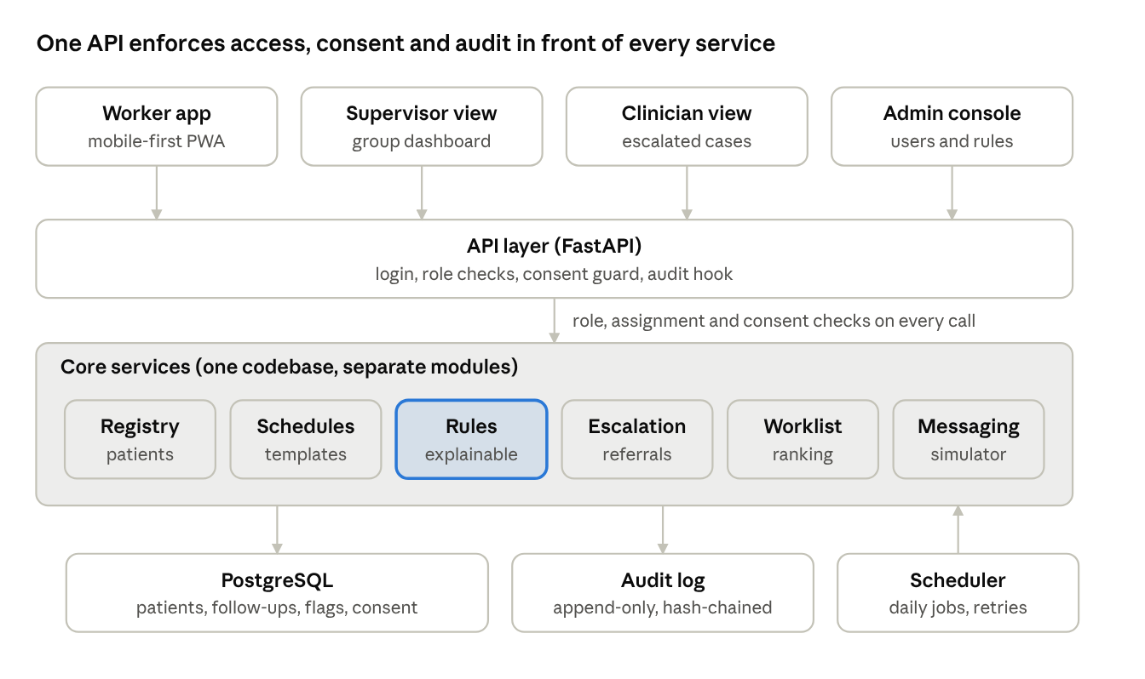
system architecture · 4 clients, 1 API, 6 modules, 3 stores
Clients never touch the database. Every request passes the API layer, which checks role, patient assignment and consent before a module runs, and writes an audit entry afterwards. The scheduler calls the same modules as the API, so automated and manual actions follow identical rules.
Data flow for one clinical alert: a check-in arrives (worker app or simulated message reply), the Registry stores it, the Rules module evaluates it and stores a flag with its explanation, the Worklist module re-ranks, the worker escalates, the Escalation module creates a tracked case, the clinician responds, and each step is written to the audit log.

3. Data model
Thirteen core tables. Sensitive columns are marked; everything uses UUID keys and UTC timestamps (shown in IST in the UI).
Table | Purpose | Key fields | Notes
users | Staff accounts | id, role, name, password_hash, facility_id, active | Roles: worker, supervisor, clinician, admin
facilities | Health centre or sub-centre | id, name, district | Used for grouping
patients | Minimal registry | id, pseudonym, age_band, village, cohort, language, assigned_worker_id, status | Phone stored in a separate encrypted table
patient_contacts | Contact details | patient_id, phone_enc, preferred_channel | Encrypted, readable only by the assigned worker and the messaging job
consents | Consent record | id, patient_id, purpose, channel, language, granted_at, withdrawn_at | Checked on every access and send
schedule_templates | Cohort follow-up rules | id, cohort, interval_days, grace_days, reminder_offsets, version | Admin-edited and versioned
followups | Individual due visits | id, patient_id, due_date, status, completed_at, template_version | Status: scheduled, due soon, overdue, missed, completed, cancelled
checkins | Visit or remote report | id, patient_id, followup_id, source, symptoms (list), measurements (typed values), logged_by, logged_at | Symptoms from an approved checklist only
rules | Rule definitions | id, version, class, cohort, definition (JSON), status, approved_by, approved_at | Active only after approval
flags | Raised alerts | id, patient_id, rule_id, rule_version, class, priority_score, explanation, inputs (JSON), status, raised_at, resolved_at | Explanation stored at creation time
escalations | Clinician routing | id, flag_id, requested_by, clinician_id, status, deadline, summary (JSON), outcome, referral_destination | One open escalation per flag
messages | Simulated messages | id, patient_id, template, status, sent_at, reply | No clinical content in text
audit_log | Append-only history | id, timestamp, actor_id, role, action, patient_pseudonym, object_ref, before, after, reason, prev_hash | Insert-only database permissions
Relationships in one line: a patient has many consents, follow-ups, check-ins, flags and messages; a flag may have one escalation; every table change is mirrored by an audit entry.
Minimization choices: age band not birth date, village not address, pseudonym not name in clinician views, symptoms as codes not free text, and an enforced retention date on archived records.

4. Rules engine and explainability
The engine is a pure function: given a patient context and the active rule set, it returns flags with explanations. It has no hidden state and no learned model.
Rule definition (stored as JSON; thresholds are illustrative placeholders)
{
"id": "CLIN-BP-02",
"version": 1,
"class": "clinical_review",
"cohorts": ["hypertension", "pregnancy"],
"inputs": ["systolic_bp"],
"condition": { "any": [
{ "latest_above": 160 },
{ "rising_over": 3 }
]},
"threshold_source": "clinician-configured, illustrative",
"explain_template": "Last {n} readings: {values}. Configured limit: {limit}. Rule {id} v{version}. Prompt for review, not a diagnosis.",
"status": "active",
"approved_by": "clinician_id"
}
Evaluation steps
- Load the active rule versions for the patient's cohort.
- Build the context (latest symptoms, last N measurements, schedule status).
- Evaluate each condition with a small, whitelisted operator set (above, below, rising_over, missing_for, count_in_window).
- For each match, fill the explain template with the real values and store the inputs used.
- Compute the priority score and return flags, which the service dedupes against active flags.
Priority score (shown to the user, never hidden)
score = 100 \cdot [\text{clinical}] + 10 \cdot \text{days overdue} + 15 \cdot \text{stacked flags} + w_{\text{cohort}}
The weights are admin-configurable constants; the worklist shows the term-by-term breakdown. The operators are intentionally limited, so a rule cannot run arbitrary code.
Explainability guarantees
- Every flag stores rule ID, rule version, input values and the final text.
- Old flags keep their original explanation even after a rule changes.
- A "Test this rule" screen lets a clinician replay a rule against the synthetic registry before approving it.

5. API design
REST over HTTPS with JSON. All endpoints require a valid session; the role and assignment checks are applied by shared middleware, so a new endpoint cannot skip them.
Method and path | Purpose | Roles
POST /auth/login | Issue a session token | All
GET /patients | List the caller's assigned patients (filtered by role) | Worker, supervisor
POST /patients | Enrol a synthetic patient with consent | Worker
POST /patients/{id}/consent | Grant or withdraw consent | Worker
GET /patients/{id} | Minimal profile, schedule, active flags | Worker, clinician (escalated only)
POST /patients/{id}/checkins | Log symptoms and measurements; triggers rule evaluation | Worker
GET /worklist | Ranked flags and follow-ups for today, with score breakdown | Worker
GET /flags/{id}/explain | "Why flagged" detail: rule, inputs, version | Worker, supervisor, clinician
POST /flags/{id}/escalate | Create an escalation | Worker, supervisor
POST /escalations/{id}/ack | Clinician acknowledges | Clinician
POST /escalations/{id}/outcome | Record review result, referral and outcome | Clinician
GET /dashboard/supervisor | Group counts: overdue, flags by class, stuck escalations | Supervisor
POST /messages/send | Send an approved template via the simulator | Worker, supervisor
POST /sim/inbound | Simulated patient reply webhook | System (simulator)
GET/PUT /admin/schedules, /admin/rules | Manage versioned schedules and rules | Admin (rules need clinician approval)
GET /audit | Filtered audit log | Admin, supervisor (own group)
Response conventions: every flag payload includes class, reason, rule_id, rule_version and a disclaimer string; errors never reveal whether a patient exists to an unauthorized caller (a uniform 403).

6. Security, privacy and access architecture
Control | Implementation
Authentication | Password login with argon2 hashes, short-lived JWT, session timeout and logout on role change
Authorization (RBAC) | Role claims checked by middleware; each route declares its allowed roles in code
Patient-level access | Worker sees only assigned patients; supervisor only their group; clinician only escalated cases, enforced in queries and by Postgres row-level security
Consent guard | Shared dependency that blocks read, write and send when consent is missing or withdrawn; applies to jobs too
Encryption | TLS in transit; phone numbers encrypted at the application level with a key held outside the database
Data minimization | Schema carries no names, addresses, national IDs or free-text clinical notes; clinician views show pseudonyms
Audit | Append-only table, database user can insert but not update or delete, each row hashes the previous one; nightly verification job
Secrets | Environment variables and a secrets file excluded from the repository
Input safety | Pydantic validation on every payload, parameterized queries, output encoding in the UI
Rate limiting | Per-user and per-IP limits on login and messaging endpoints
Safe errors | Uniform 403 for unauthorized object access; no stack traces to clients
Synthetic-only guard | A startup check refuses to run in "demo" mode with non-synthetic flagged data
Threats considered: account sharing between workers (per-user audit and session limits), over-broad supervisor access (group scoping), alert fatigue leading to ignored flags (two-class design and caps), tampering with history (hash-chained audit), and accidental real data entry (synthetic-only guard and banner).

7. Messaging simulation layer and background jobs
Gateway interface. The Messaging module talks to an interface with three methods: send(template, recipient), status(message_id) and an inbound webhook receive(reply). The prototype implements it with a simulator that stores messages in the database, shows them in a demo "phone" panel, and can inject delays, failures and replies. Replacing it with a real SMS or WhatsApp Business provider later means writing one new adapter; no other module changes.
Simulator controls (demo panel): deliver now, delay, fail, reply with 1, 2, STOP or unknown text.
Job runner
Concern | Approach
Scheduling | APScheduler cron triggers inside the backend process; upgradable to Celery with Redis
Idempotency | Each job writes a run key (job, date, entity); a repeat run skips finished work
Concurrency | Database advisory locks so only one instance of a job runs
Retries | Exponential backoff for sends; a failed job raises an admin alert and a dashboard banner
Time handling | Stored in UTC, scheduled and displayed in IST
Demo control | An admin-only "advance clock" tool replays a day of jobs on demand, so judges can see overdue detection live

8. Deployment, testing, observability and build plan
Deployment
- Local and demo: Docker Compose with three containers (web, API, PostgreSQL), seeded with the synthetic registry on first start.
- Hosted fallback: free-tier hosting for the web app and API plus a managed Postgres, so judges can open a link.
- Config through environment variables; one seed command resets the demo to a known state.
Testing
Layer | What we test | Proof for judges
Rules | Each seeded scenario produces exactly the expected flag and explanation | Test report: all seeded cases pass
RBAC | Every role against every endpoint, plus wrong-patient access | Access matrix test table
Consent | Messaging and entry blocked after withdrawal | Automated test and live demo
Jobs | Re-running a job creates no duplicates | Idempotency test
UI | Worklist to escalation path in the browser | Scripted demo run
Observability: structured logs with request IDs (no patient data in logs), a job-run history page, and an admin health card showing last run times and failures.
Hackathon build plan (adjust to your remaining time)
Block | Deliverable
1. Foundation | Repo, Docker Compose, database schema, login and roles, seed generator
2. Core loop | Registry, consent, schedules, check-ins, overdue detector
3. Intelligence | Rules engine, flags with explanations, worklist ranking
4. Workflow | Messaging simulator, escalation and referral tracking, audit log
5. Polish | Supervisor and clinician views, prototype banners, translations, test run
6. Submission | Demo script, recorded fallback video, README, these four docs
Team split suggestion for four people: one on backend and rules, one on frontend worklist and mobile UX, one on data, tests and messaging simulator, one on docs, demo script and pitch.

